CSA1708 – ARTIFICIAL INTELLIGENCE LAB EXPERIMENTS

Program 4: Crypt-Arithmetic Problem

Aim
To develop a Python program to solve a Crypt-Arithmetic Problem by assigning unique digits to different letters such that the given arithmetic equation is satisfied.

Algorithm
- Identify all unique letters in the given words.
- Assign a different digit to each letter.
- Ensure that the first letter of each word is not zero.
- Substitute the digits for the letters.
- Check whether the arithmetic equation is satisfied.
- If a valid assignment is found, display the solution.
- If no assignment is found, report that no solution exists.
Program
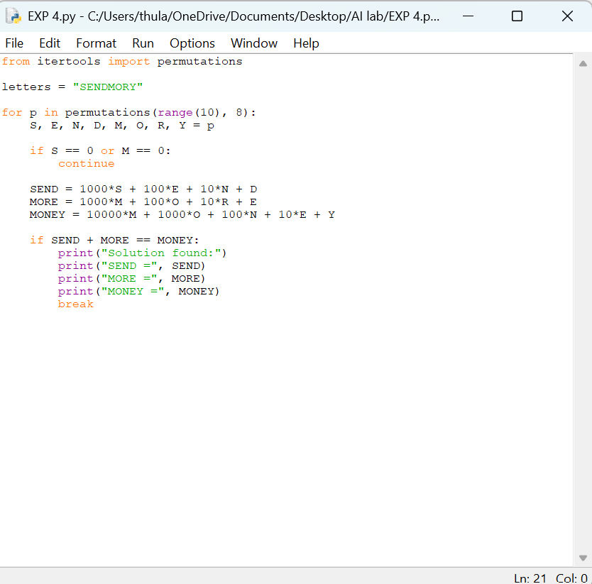
Output
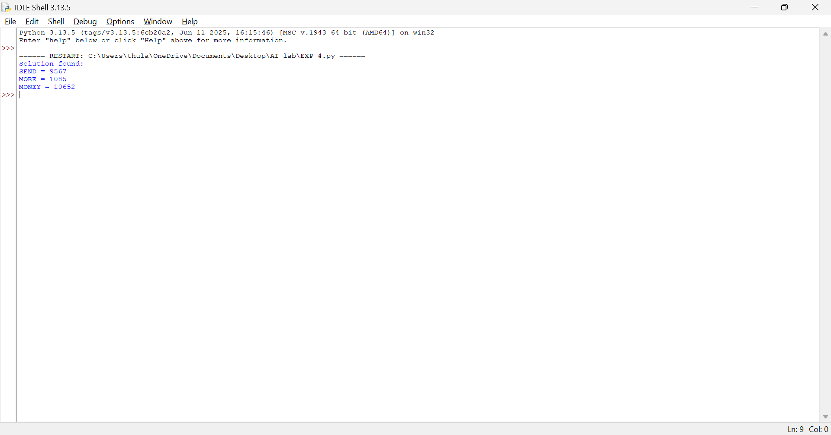

Result
Thus, the Crypt-Arithmetic Problem was solved successfully using Python.

Program 5: Missionaries and Cannibals Problem

Aim
To develop a Python program to solve the Missionaries and Cannibals Problem using a state-space search technique while ensuring that the missionaries are never outnumbered by cannibals.

Algorithm
- Represent a state as the number of missionaries, cannibals and boat position.
- Start with all missionaries and cannibals on the starting side.
- Generate all possible boat movements.
- Check whether each new state is valid.
- Do not allow a state where cannibals outnumber missionaries when missionaries are present.
- Keep track of visited states.
- Continue searching until all missionaries and cannibals reach the opposite side.
- Display the solution path.
Program
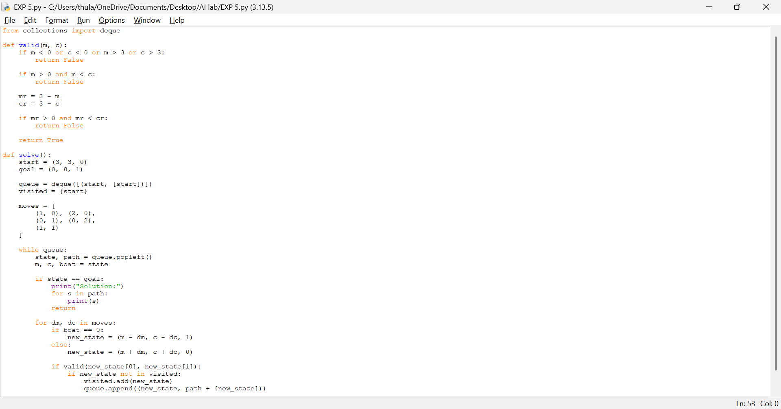

Output

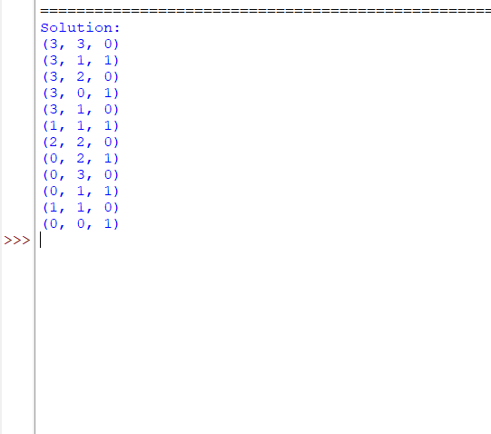

Result
Thus, the Missionaries and Cannibals Problem was solved successfully using Python.

Program 6: Vacuum Cleaner Problem

Aim
To develop a Python program to solve the Vacuum Cleaner Problem by moving the vacuum cleaner and cleaning the dirty rooms.

Algorithm
- Represent the environment with two rooms.
- Define the initial location of the vacuum cleaner.
- Check whether the current room is dirty.
- If the room is dirty, clean it.
- If the room is clean, move to the other room.
- Repeat the process until both rooms are clean.
- Display the final state.
Program
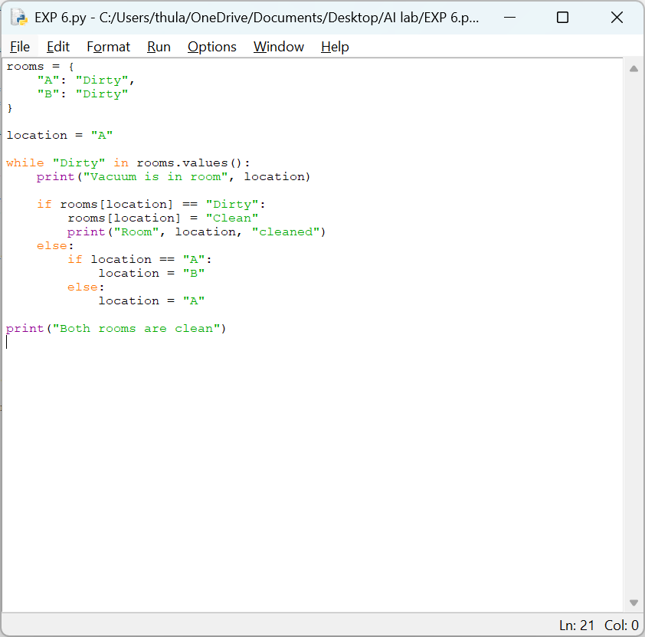
Output
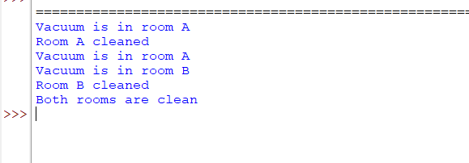

Result
Thus, the Vacuum Cleaner Problem was solved successfully using Python.
Program 7: Breadth-First Search (BFS)

Aim
To develop a Python program to implement Breadth-First Search (BFS) for traversing a graph level by level.

Algorithm
- Represent the graph using an adjacency list.
- Select the starting node.
- Create a queue and add the starting node.
- Mark the starting node as visited.
- Remove a node from the queue and display it.
- Add all unvisited adjacent nodes to the queue.
- Repeat until the queue becomes empty.
- Display the BFS traversal.

Program
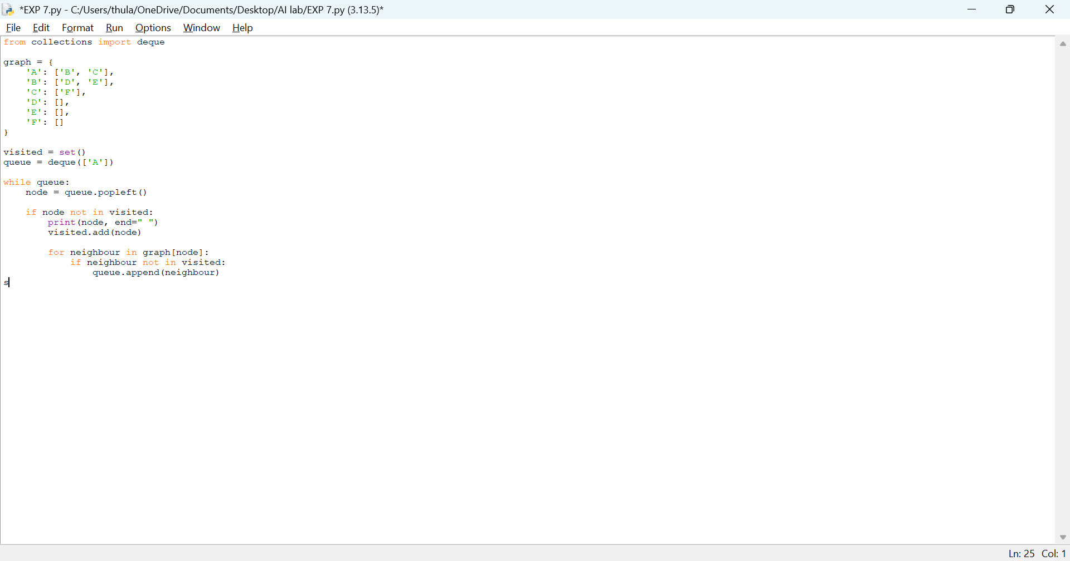

Output

Result
Thus, Breadth-First Search (BFS) was implemented successfully using Python.

Program 8: Depth-First Search (DFS)

Aim
To develop a Python program to implement Depth-First Search (DFS) for traversing a graph.

Algorithm
- Represent the graph using an adjacency list.
- Select the starting node.
- Mark the starting node as visited.
- Display the node.
- Visit an unvisited adjacent node.
- Continue until there are no unvisited adjacent nodes.
- Backtrack to the previous node.
- Repeat until all reachable nodes are visited.
Program
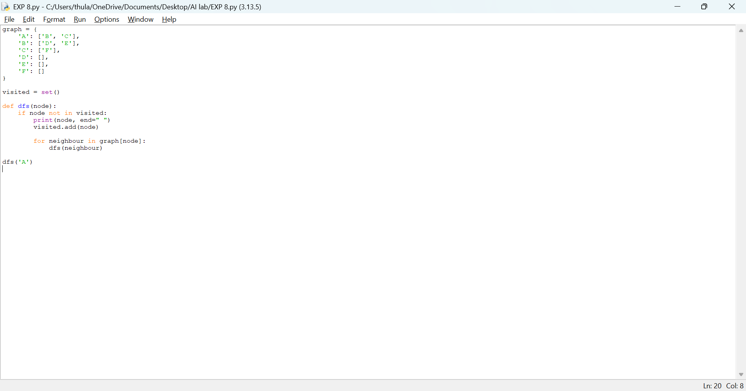

Output

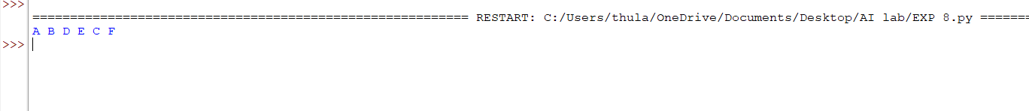

Result
Thus, Depth-First Search (DFS) was implemented successfully using Python.

Program 9: Travelling Salesman Problem

Aim
To develop a Python program to solve the Travelling Salesman Problem (TSP) by finding the minimum-cost route that visits all cities exactly once and returns to the starting city.

Algorithm
- Represent the distances between cities using a distance matrix.
- Select the starting city.
- Generate all possible routes.
- Calculate the total distance of each route.
- Compare the total distances.
- Select the route with minimum distance.
- Display the minimum route and its cost.
Program

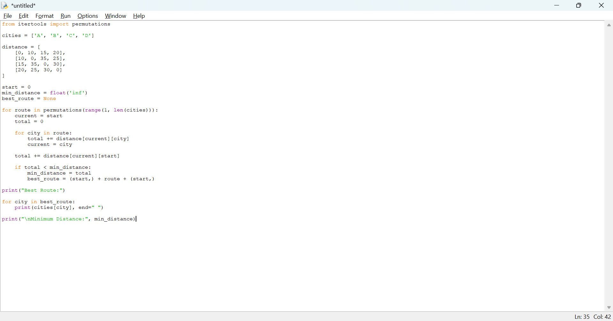

Output
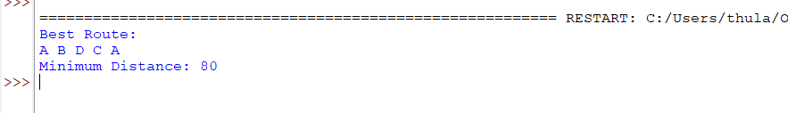

Result
Thus, the Travelling Salesman Problem was solved successfully using Python.

Program 10: A* Algorithm

Aim
To develop a Python program to implement the A* algorithm for finding the shortest path between a starting node and a goal node using cost and heuristic values.

Algorithm
- Define the graph and heuristic values.
- Set the starting node.
- Calculate the cost function f(n) = g(n) + h(n).
- Select the node with the lowest f(n) value.
- Expand its neighbouring nodes.
- Calculate the cost for each neighbouring node.
- Continue the process until the goal node is reached.
- Display the shortest path and its total cost.
Output
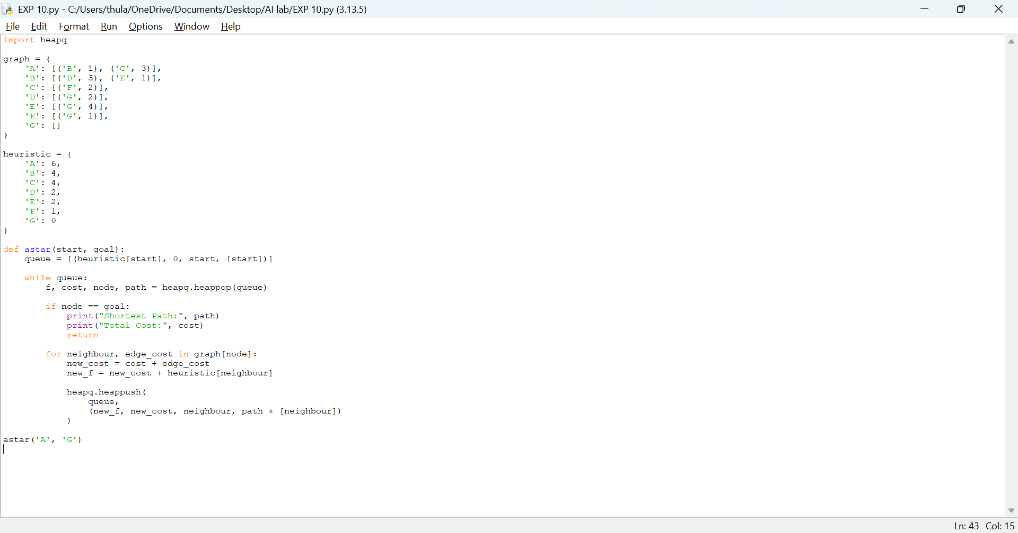

Output

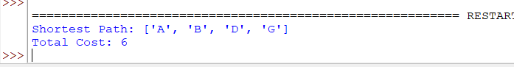

Result
Thus, the A* algorithm was implemented successfully using Python to find the shortest path.

